CSA1717-ARTIFICIAL INTELLIGENCE
PRACTICAL LAB EXPERIMENTS
NIHARIKA PREEJESH (192524506)

PROGRAM 9: CRYPT ARITHMETIC
Aim:
To implement the Crypt Arithmetic problem by assigning unique digits to letters such that the given arithmetic equation is satisfied.
Algorithm
- Read the crypt arithmetic equation.
- Identify all unique letters.
- Assign unique digits (0–9) to each letter.
- Ensure that no leading letter is assigned zero.
- Check whether the arithmetic equation is satisfied.
- Display the valid solution if found.
- Otherwise, report that no solution exists.

Flowchart:
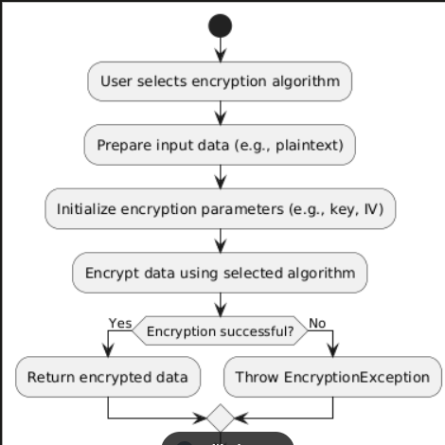

Output:
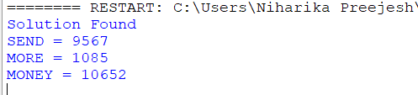

Result:
Thus, the Crypt Arithmetic problem was implemented successfully, and the correct digit assignment satisfying the given equation was obtained.

